ABER CHARITY EDNA

M23B13/001

B20244

**PROJECT: STUDENT ATTENDANCE BY USING FINGERPRINT READER.**

**Fact-Finding:**

* Taking attendance in class is often a time-consuming process especially in larger classes. Developing a fingerprint reader system that automates the attendance of students daily would make it simplified and fast.

**Problem:**

* Manual student attendance tracking processes, which are prone to inaccuracies, manipulation, and time consumption.

**Solution:**

* To address the challenges of manual attendance systems, a Fingerprint-Based Attendance System offers an automated, secure, and efficient way to track student attendance for only authorized students.

**Benefits of the System**:

1. Real-time monitoring and reports (monitor attendance in real time)
2. Security (only authorized parties like admins have access to student information)
3. Accuracy (reduces human errors)
4. Scalability

**Cut over:**

Process of transitioning from the existing manual sign-in sheets method to the new system that uses fingerprint biometric.

Steps involved in the cut over process.

1. Hardware installation– Install the necessary fingerprint readers at the entrance of classrooms or lecture halls.
2. Software setup- Install and configure the necessary software on the central server
3. User training – Train students, staff on how to use the fingerprint reader.
4. Testing - Conduct a pilot test to a few classes to identify any issues before full scale implementation in the institution.

**How it works**

Student Registration:

* A new student is registered by scanning their fingerprint, which is stored in the system along with their personal details.

Attendance Marking:

* The student places their finger on the reader at the start of a class.
* The fingerprint is scanned and compared to the records in the system database.
* If the fingerprint matches, attendance is recorded with the current date and time.

Data Storage:

* The attendance record is stored in the central database, accessible by teachers and admins.

Report Generation:

* Admins can generate attendance reports for individual students, specific classes, or the entire student body.

**USE CASE:**

A use case visually represents how different users/actors interact with the system and their key roles as seen below;

**Actors/users**

* Student/Staff
* Administration/ Teachers/ Lecturers
* Finger print reader.

**Key Use Cases**

1. Register attendance:

Actor: Student

Description: A student scans their finger on the fingerprint reader and then the system records their timestamp for attendance.

1. Verify fingerprint

Actor: Finger print device

Description: It compares the finger print scanned with the finger prints captured in the database for verifying the identity of the student/ staff.

1. View attendance report

User: Administration / staff with permission

Description: The admin can generate attendance reports for all students for a particular period or day.

1. Register new students

Actor: Administration

Description: The admin registers new students’ details including capturing their fingerprint.

1. Generate attendance summary

Actor: Admin

Description: Generates daily, weekly, monthly attendance summaries based on the collected data.

1. Manage Student information

Actor: Admin

Description: The admin can update, modify student data in the system.

### **System**

* **Application**: The main software system that interacts with both the biometric scanner and the admin dashboard.

**USE CASE DIAGRAM.**

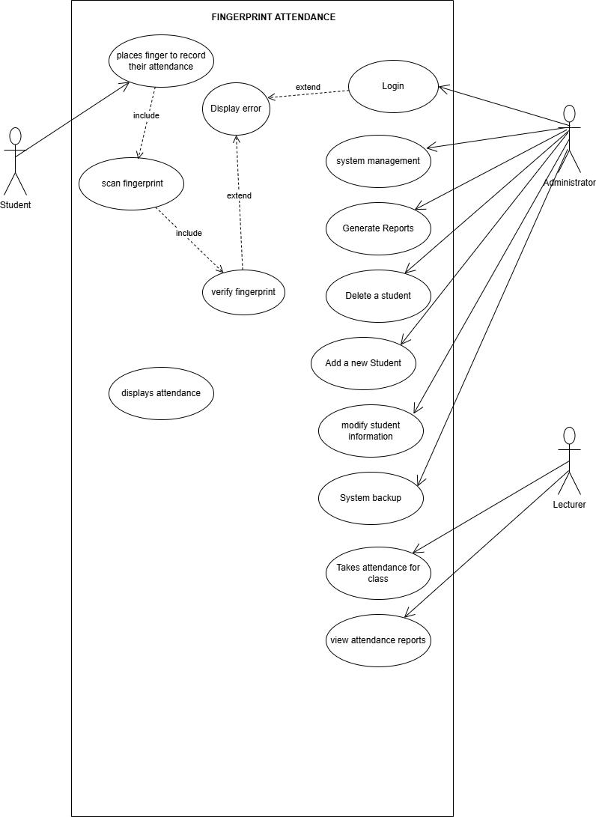

**Key Functional Components**

* Fingerprint Scanner Module: Scans the student's fingerprint for attendance and also verifies it.
* Fingerprint Verification Module: Verifies the fingerprint by comparing it with the stored database.
* Database Management: Provides fingerprint records for verification and saves attendance data.
* Attendance Record Module: Registers and timestamps attendance entries. Interacts with the Database Management Module for data retrieval
* Admin Interface: Allows the admin to manage student data, view reports, and register new students.
* Report Generation Module: Generates attendance reports based on data in the Database. Sends reports to the admin interface

**SEQUENCE DIAGRAM**

A sequence diagram shows the interaction between the system components over time.

Actors

* Student
* Admin

Objects

* Fingerprint reader
* Central server
* System database
* Attendance List

**Steps**

* A student places their finger on the fingerprint scanner
* The fingerprint captures the fingerprint and sends it to the system.
* System databases verify the fingerprint by comparing it to the stored records in the database system.
* If a match is found, the System Database stores the attendance record (with timestamp).
* The System sends a confirmation to the Fingerprint Device.
* The Fingerprint Device shows success feedback to the student.
* The admin can later access the attendance report generated by the System Database.
* The lecturer can request for a report from the admin which is retrieved by the system database.

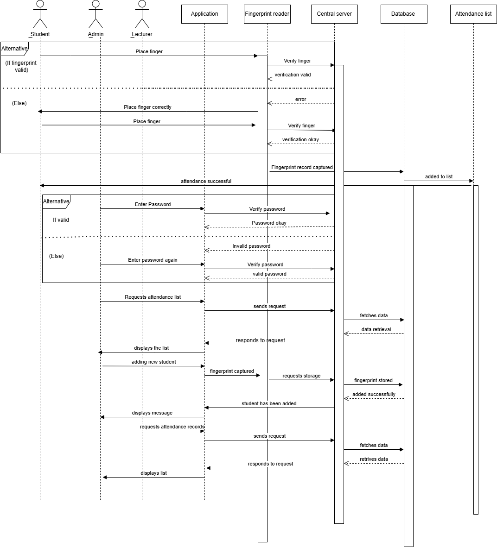

**CLASS DIAGRAM**

**Relationships:**

* Student interacts with Fingerprint Reader to scan their fingerprint.
* Admin manages Student information(add, delete, modify student information) and views Attendance Record.
* System-database is responsible for storing and retrieving data for both Student and Attendance Record.
* Fingerprint Reader communicates with System-database to verify the scanned fingerprint.
* Admin can either generate individual student reports or overall reports using the Report Generation class methods.

**Aggregation:**

* Attendance Record aggregates multiple instances into a list (history of attendance)

**DIAGRAM**

